# freETarget

Application Note: Going Wireless

**SUMMARY**

This application note details the components and configuration needed to implement a wireless connection.

The application

**REQUIRED**

|  |  |  |
| --- | --- | --- |
| Item | Description | Obtained From |
| 1 | freETarget V2.2 or higher |  |
| 2 | freETarget firmware V3.2 or higher |  |
| 3 | ESP-01 | Amazon <https://www.amazon.com/Wireless-Transceiver-Receiver-DC3-0-3-6V-Compatible/dp/B07R4MXPLF/ref=sr_1_12?crid=3V1D0J59OCRTH&dchild=1&keywords=esp-01&qid=1624114287&sprefix=esp-01%2Caps%2C169&sr=8-12>  Or Similar |
| 4 | ESP-01 5Volt Adapter | Amazon <https://www.amazon.com/Aideepen-ESP8266-Wireless-Adapter-Compatible/dp/B01M09B43H/ref=sr_1_3?dchild=1&keywords=esp-01+5V&qid=1624114362&sr=8-3>  Or Similar |
| 5 | 6 Pin IDC Connector | Digikey https://www.digikey.com/en/products/detail/te-connectivity-amp-connectors/3-640441-6/698225  Or Similar |
| 6 | 24 Guage Hookup Wire |  |

**INTRODUCTION**

freETarget supports a WiFi connection using the accessory connector and an off-the-shelf ESP-01 Serial WiFi transceiver. Using the ESP-01, freETarget appears as a WiFi hotspot that when a connection is made transmits the score JSON message to the PC program.

Installing the ESP-01 consists of the following steps

* Build the ESP-01 interface
* Attach the ESP-01 to freETarget
* Select the target name
* Power Up
* On the PC choose the freETarget SSID for your target
* Use the bridge application freeTargetWiFi2Com to connect the target to the program

**ASSEMBLING THE WiFi INTERFACE**

**Building the ESP-01 Adapter**

The ESP-01 is a self-contained circuit that operates at 3.3 Volts. freETarget operates at 5.0 Volts, so connecting an ESP-01 directly to the board will damage the ESP-01 circuit. Fortunately, adapter circuits are available that convert the voltage levels. Install the ESP-01 into the adapter as shown in Figure 1.

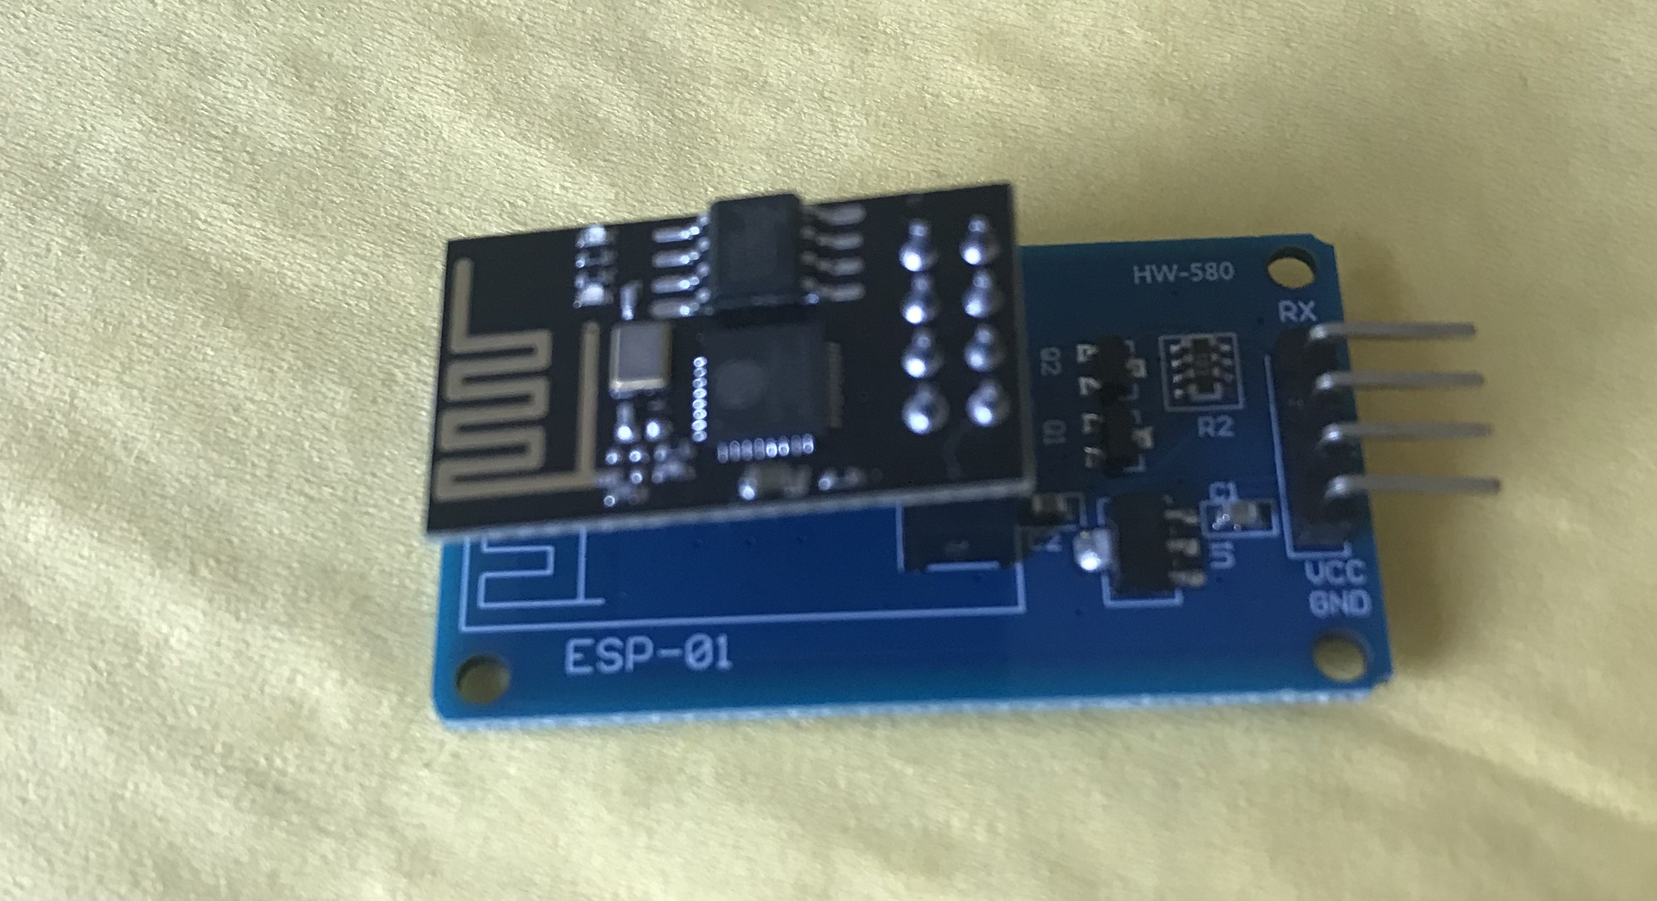

Figure 1: ESP-01 and Adapter Assembly

The ESP-01 and freETarget connect to each other using a short six pin connector illustrated in Figure 2. While the ESP-01 adapter uses four pins and freETarget uses six, for the purposes of convenience two six pin connectors can be used.

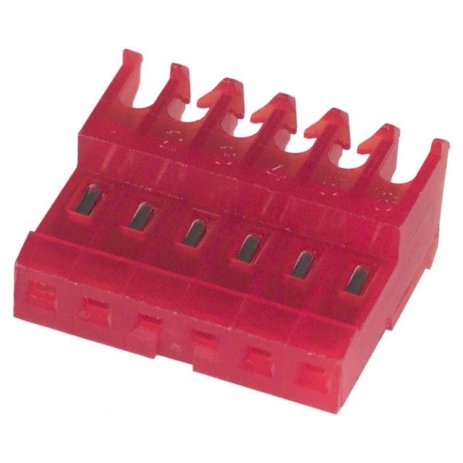

Figure 2: Sample IDC Connector

The wiring for each of the connectors is found in Table 1.

Table 1: WiFI Cable Harness

|  |  |  |
| --- | --- | --- |
| freETarget  Connector | Description | ESP-01  Connector |
| 1 | 5VDC | 2 |
| 2 | Auxiliary Transmit Data | 4 |
| 3 | Auxiliary Receive Data | 3 |
| 4 | Motor Drive (Not Used) |  |
| 5 | Spare (Not Used) |  |
| 6 | Ground | 1 |

**Connect the ESP-01 to freETarget using the cable harness.**

IMPORTANT

When connecting the cable harness to the ESP-01, ensure that Pin 1 of the connector mates to Pin 1 of the adapter. Pins 5 and 6 will overhang the board and not be connected.

**Naming the Target**

freETarget allows you to assign a name to each target for identification. This name appears in the SSID of the WiFi sources on your computer. If you are using a single lane freETarget, the default name “FET-TARGET” can be used for the SSID.

In larger installations a name can be chosen from Table. Use NAME setting found in the PC program setup tab.

Table 2: freETarget Lane Names

|  |  |
| --- | --- |
| Name ID |  |
| 0 | TARGET |
| 1-10 | Numeric 1-10 |
| 11-18 | Seven Dwarfs  “DOC", "DOPEY", "HAPPY", "GRUMPY", "BASHFUL", "SNEEZEY", "SLEEPY" |
| 19-27 | Eight Reindeer  "RUDOLF", "DONNER", "BLITXEM", "DASHER", "PRANCER", "VIXEN", "COMET", "CUPID", "DUNDER" |
| 28-32 | Norse Gods  "ODIN", "WODEN", "THOR", "BALDAR" |

**freeTargetWiFi2Com**

This is a simple go based app to bridge between the USB/COM port on the freETarget at and the wifi enabled freETarget. You can download it at the downloads page https://free-e-target.com/downloads/

This version forwards messages from the target to the pc software. It relies on a COM paring driver such as <http://com0com.sourceforge.net/> It assumes that the target is using the default ip address of 192.168.10.9 port 1090, and that the pc software is listening on COM8.

To use the bridge first configure the pc software to listen on COM8, click the connect button in the top left on the pc software, then start wifi2com.exe either by double clicking on it in explorer or run it from a command line.

Once the bridge has started it will display a message from the target with the version number, the PC Software will then show that it is connected after a few seconds.

Each shot data will be displayed in the bridge output as it forwards it to the PC Software.

If COM8 and COM9 are not available then you need to create a different pair with the COM pairing driver, for example COM1 and COM2, configure the PC software to listen on COM1, then you can use the following syntac to run the bridge to connect to COM2.

wifi2com.exe -port=COM2

**SPECIFICATIONS**

When an ESP-01 is attached to freETarget, the firmware will detect the ESP-01 and automatically configure the connection.

**SSID**

The WiFi SSID connection will take on the name of the target, FET-<name>. For example FET-TARGET or FET-RUDOLF.

**freETarget IP Address**

The freETarget IP address is fixed and is 192.168.10.9

**PC IP Address**

The ESP-01 contains a DHCP server and will assign the PC an address of 192.168.10.0

**Server Connection**

The PC acts as a client to freETarget, and connects to freETarget on port 1090